Outpatient Clinics
LycaHealth – Orpington
Our outpatient department includes 13 consultation rooms where patients can see consultants.
We also have a diagnostic imaging suite with access to MRI, CT, X-Ray and Ultrasound, a physio service with an anti-gravity treadmill and gym.

Outpatient services, providing access to world class clinicians and care in the following areas;

- Aesthetics
- Audiology
- Cardiology
- Dermatology
- Endocrinology
- ENT
- Gastroenterology
- General Medicine
- Gynaecology
- Haematology
- Neurology
- Neurosurgery
- Ophthalmology
- Orthopaedic
- Paediatric
- Psychiatry
- Renal Medicine
- Respiratory
- Rheumatology
- Sports and MSK
- Urology

We welcome and accept patient referrals from the UK and worldwide and are accredited with all major insurance companies. Self-Funding patients are also welcome and prices are available upon request.

Open – Monday to Friday: 8am to 8pm (Saturdays upon requests)
All bookings are made on an appointment basis for specialist consultations and imaging.
We can offer same day diagnostic imaging appointments where possible.

Should you wish to refer a patient or have any enquiries about the services on offer please contact the number below;

Tel: 01689 490111
Orders@lycahealth.com
www.lycahealth.com

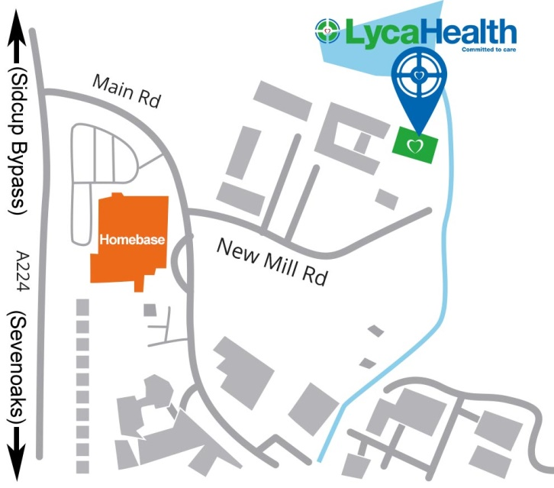

Enso House
3 New Mill Road
Orpington
BR5 3TW
If you would like to speak to someone to discuss what LycaHealth can do for you, then please contact our GP Liaison Manager:

Ian Vallance
(m) 07584 620925
(e) ian.vallance@lycahealth.com

